# https://upload.wikimedia.org/wikipedia/en/f/f1/Capital_University%2C_Jharkhand_logo.png

# CAPITAL UNIVERSITY - KODERMA

POWER ELECTROINCS ASSIGNMENT

Name : Arshad Nazir

Electrical and Electronics Engineering

Signature:

Date :

**1. Why IGBT is very popular nowadays?**

IGBT stands for insulated-gate bipolar transistor. It is a bipolar transistor with an insulated gate terminal. The IGBT combines, in a single device, a control input with a MOS structure and a bipolar power transistor that acts as an output switch. IGBTs are suitable for high-voltage, high-current applications.

IGBTs are widely used as switching devices in the inverter circuit (for DC-to-AC conversion) for driving small to large motors. IGBTs for inverter applications are used in home appliances such as air conditioners and refrigerators, industrial motors, and automotive main motor controllers to improve their efficiency.

With its lower on-state resistance and conduction losses as well as its ability to switch high voltages at high frequencies without damage makes the Insulated Gate Bipolar Transistor ideal for driving inductive loads such as coil windings, electromagnets and DC motors.

1. **What is the difference between power diode and signal diode ?**

Power diode is constructed with n-layer, called drift region between the p+ layer and n+ layer. In Signal diode, the drift region is not present.

The voltage, current, and power ratings are higher in the power diode while it is lower in the signal. Power diodes operate at high speeds while Signal diode operates at higher switching speed.

1. **IGBT is a voltage controlled device. Why ?**

IGBT is a voltage controlled device because the controlling parameter is gate - emitter voltage.

1. **Power MOSFET is a voltage controlled device. Why ?**

Power MOSFET is a voltage controlled device because the output (drain ) current can be controlled by gate - source voltage.

1. **Power BJT is a current controlled device. Why ?**

Power BJT is a current controlled device because the outside (collector) current can be controlled by base current.

1. **What are the different types of power MOSFET ?**

The different types of power MOSFET are :

1. N-channel MOSFET
2. P- channel MOSFET
3. **Define latching current**

Latching current is the minimum anode current required to maintain the thyristor in the ON state immediately after thyristor has been turned on and the gate signal has been removed.

1. **Define holding current**

Holding current is the minimum anode current to maintain the thyristor in the ON state.

1. **What is a snubber circuit ?**

Snubber circuits are essential for diodes used in switching circuits. It can save a diode from overvoltage spikes, which may arise during the reverse recovery process. A very common snubber circuit for a power diode consists of a capacitor and a resistor connected in parallel with the diode.

1. **What circuit turn off time**

Circuit turn off time is defined as the time as the time during which a reverse voltage is applied across the thyristor during its communication process.

1. **Why circuit turn off time should be greater than the thyristor turn off time**

Circuit turn off time should be greater than the thyristor turn off time for reliable turn off, otherwise the device may turn on at an undesired instant, a process called communication failure.

1. **What is the turn -off time for converter grade SCRs and inverter grade SCRs ?**

Turn -off time for converter grade SCRs is 50 - 100 ms Turn -off time for inverter grade SCRs is 3 - 50 ms

1. **What are the advantages of GTO over SCR ?**

The advantages of GTO over SCR are :

1. Elimination of commutation of commutating components in forced commutation, resulting in reduction in cost, weight and volume.
2. Reduction in acoustic noise and electromagnetic noise due to elimination of commutation chokes.
3. Faster turn-off, permitting high switching frequencies. Improved efficiency of the converters.
4. **What is meant by phase controlled rectifier ?**

Phase controlled rectifier converts fixed ac voltage into variable dc voltage.

1. **What is the function of freewheeling diodes in controlled rectifier ?**

Freewheeling diodes has 2 functions in controlled rectifier . They are :

1. It prevents the output voltage from becoming negative.
2. The load current is transferred from the main thyristors to the freewheeling diode, thereby allowing all of its thyristors to regain their blocking states.
3. **What are the advantages of freewheeling diodes in a controlled in a controlled rectifier ?**
4. Input power factor is improved.
5. Load current waveform is improved and thus the load performance is better.
6. **What is meant by delay angle ?**

The delay angle is defined as the angle between the zero crossing of the input voltage and the instant the thyristor is fired.

1. **What is commutation angle or overlap angle ?**

The commutation period when outgoing and incoming thyristors are conducting is known as overlap period. The angular period , when both devices share conduction is known as the commutation angle or overlap angle.

1. **What are the different methods of firing circuits for line commutated converter ?**

There are 3 different methods of firing circuits for line commutated converter. They are :

1. UJT firing circuit
2. The cosine wave crossing pulse timing control
3. Digital firing schemes.
4. **What are the advantages of six pulse converter ?**
5. Commutation is made simple.
6. Distortion on the ac side is reduced due to the reduction in lower order harmonics.
7. Inductance reduced in series is considerably reduced.
8. **What is meant by commutation ?**

Commutation is the process of changing the direction of current flow in a particular path of circuit. This process is used in thyristors for turning it off.

1. **What are the types of commutation ?**

There are 2 types of commutation. They are :

1. Natural commutation
2. Forced commutation
3. **What is meant by natural commutation ?**

In natural commutation, the current flowing through the thyristor goes through a natural zero and enable the thyristor to turn off.

1. **What is meant by forced commutation ?**

In forced commutation, the current flowing through the thyristor is forced to become zero by external circuitry.

1. **What is meant by dc chopper ?**

A dc chopper is a high speed static switch used to obtain variable dc voltage from a constant dc voltage.

1. **What are the applications of dc chopper ?**

Some of the applications of dc chopper are :

1. Battery operated vehicles
2. Traction motor control in electric traction
3. Trolley cars
4. Marine hoists
5. Mine haulers
6. Electric braking

**37. What is meant by step-up and step-down chopper ?**

In a step-down chopper or Buck converter, the average output voltage is less than the input voltage. In a step-up chopper or Boost converter, the average output voltage is more than the input voltage.

1. **What is meant by duty-cycle ?**

Duty cycle is defined as the ratio of the on time of the chopper to the total time period of the chopper. It is denoted as α .

1. **What are the two types of control strategies ?**

The two types of control strategies are :

1. Time Ratio Control (TRC)
2. Current Limit Control method (CLC)
3. **What are the different types of chopper with respect to commutation process ?**

There are 3 types of chopper with respect to commutation process. They are :

1. Voltage commutated chopper
2. Current commutated chopper
3. Load commutated chopper
4. **What is meant by voltage commutation ?**

In voltage commutation, a charged capacitor momentarily reverse biases the conducting thyristor and turn it off.

1. **What is meant by current commutation ?**

In current commutation, a current pulse is made to flow in the reverse direction through the conducting thyristor and when the net thyristor current becomes zero,it is turned off.

1. **What is meant by load commutation ?**

In load commutation, the load current flowing through the thyristor either becomes zero or is transferred to another device from from the conducting thyristor.

1. **What are the advantages of current commutated chopper ?**
2. The capacitor always remains charged with the correct polarity.
3. Commutation is reliable as load current is less than the peak commutation current ICP.
4. The auxiliary thyristor TA is naturally commutated as its current passes through zero value.
5. **What are the advantages of load commutated chopper ?**
6. Commutating inductor is not required.
7. It is capable of commutating any amount of load current.
8. It can work at high frequencies in order of kHz.
9. Filtering requirement are minimal.
10. **What are the disadvantages of load commutated chopper ?**
11. For high power applications, efficiency becomes very low because of high switching losses at high operating frequencies.
12. Freewheeling diode is subjected to twice the supply voltage.
13. Peak load voltage is equal to twice the supply voltage.
14. The commutating capacitor has to carry full load current at a frequency of half chopping frequency.
15. One thyristor pair should be turned -on only when the other pair is Commutated.This can be realized by sensing the capacitor current that is alternating.
16. **What is meant by inverter ?**

A device that converts dc power into ac power at desired output voltage and frequency is called an inverter.

1. **What are the applications of an inverter ?**
2. Adjustable speed drives
3. Induction heating
4. Stand-by aircraft power supplies
5. UPS
6. HVDC transmission
7. **What are the main classification of inverter ?**

There are 2 main classification of inverter. They are :

1. Voltage Source Inverter
2. Current Source Inverter
3. **Why thyristors are not preferred for inverters ?**

Thyristors require extra commutation circuits for turn off which results in decreased complexity of the circuit. For these reasons thyristors are not preferred for inverters.

1. **How output frequency is varied in case of a thyristor ?**

The output frequency is varied by varying the turn off time of the thyristors in the inverter circuit, that is the delay angle of the thyristor is varied.

1. **Give two advantages of CSI ?**
2. CSI does not require any feedback diodes.
3. Commutation circuit is simple as it involves only thyristors.
4. **What is the main drawback of a single phase half bridge inverter ?**

It require a 3-wire dc supply.

1. **Why diodes should be connected in antiparallel with the thyristors in inverter circuits ?**

For RL loads, load current will not be in phase with load voltage and the diodes connected in antiparallel will allow the current to flow when the main thyristors are turned off. These diodes are called feedback diodes.

1. **What types of inverters require feedback diodes ?**

VSI with RL load

1. **What is meant a series inverter ?**

An inverter in which the commutation elements are connected in series with the load is called a series inverter.

**65 . What is meant a parallel inverter ?**

An inverter in which the commutating elements are connected in parallel with the load is called a parallel inverter.

1. **What is meant by McMurray inverter ?**

McMurray inverter is an impulse-commutated inverter,which relies on LC circuit and auxiliary thyristor for commutation in load circuit.

1. **What are the applications of a CSI ?**
2. Induction heating
3. Lagging VAR compensation
4. Speed control of ac motors
5. Synchronous motor starting.
6. **What is meant by PWM control ?**

In PWM control method, a fixed dc input voltage is given to the inverter and a controlled ac output voltage is obtained by adjusting the on and off periods of the inverter components. This is the most popular method of controlling the output voltage and this method is termed as PWM control.

1. **What are the advantages of PWM control ?**
2. The output voltage can be obtained without any additional components.
3. Lower order harmonics can be eliminated or minimized along with its output voltage control. As the higher order harmonics can be filtered easily, the filtering requirements are minimized.

**73. What are the methods of reduction of harmonic content ?**

1. Transformer connections
2. Sinusoidal PWM
3. Multiple commutation in each cycle
4. Stepped wave inverters

**75. What are the disadvantages of PWM control ?**

The main disadvantage of PWM control is that the SCRs are expensive as they must possess low turn-on and turn-off times.

**92. What is meant by sequence control of ac voltage regulators ?**

It means that the stages of voltage controllers in parallel triggered in a proper sequence one after the other so as to obtain a variable output with low harmonic content.

1. **What is meant by cyclo-converter ?**

Cyclo-converter converts input power at one frequency to output power at another frequency with one-stage conversion. Cyclo-converter is also known as frequency changer.

1. **What are the two types of cyclo-converters ?**

There are 2 types of cyclo-converters. They are :

1. Step-up cyclo-converters
2. Step-down cyclo-converters.
3. **What is meant by step-up cyclo-converters ?**

In Step-up cyclo-converters, the output frequency is less than the supply frequency.

1. **What is meant by step-down cyclo-converters ?**

In Step-down cyclo-converters, the output frequency is more than that the supply frequency.

1. **What are the applications of cyclo-converter ?**
2. Induction heating
3. Speed control of high power ac drives
4. Static VAR generation
5. Power supply in aircraft or ship boards
6. **What is meant by positive converter group in a cyclo converter ?**

The part of the cyclo converter circuit that permits the flow of current during positive half cycle of output current is called positive converter group.

1. **What is meant by negative converter group in a cyclo converter ?**

The party of the cyclo converter circuit that permits the flow of current during negative half cycle of output current is called negative converter group.

Part IA

# 2.

* 1. **Describe the any two methods of turn-on mechanism of SCR ?**

SCR has 2 stable states in First Quadrant

1. Forward Blocking and
2. Forward Conduction State.

Switching the SCR from forward blocking state (OFF- state) to forward conduction state (ON-state) is known as turning ON process of SCR. It is also called as triggering.

With a voltage applied to SCR, if the anode is made positive with respect to the cathode, the SCR becomes forward biased.

The SCR can be made to conduct or switching into conduction mode ( Turn- on) by following methods.

1. Forward voltage triggering
2. Temperature triggering
3. dv/dt triggering
4. Light triggering
5. Gate triggering

Forward Voltage Triggering

By increasing the forward anode to cathode voltage, the depletion layer width is also increased at junction j2.

It causes increase in minority charge carriers

This further leads to an avalanche breakdown of the junction J2 at a forward breakover voltage VBO.

In practice this method is not employed because it needs a very large anode to cathode voltage.

Once the voltage is more than the VBO, it generates very high currents which may cause damage to the SCR.

Therefore, in most of the cases this type of triggering is avoided.

Temperature Triggering

The reverse leakage current depends on the temperature.

If the temperature is increased to a certain value, the number of hole-pairs also increases.

This causes to increase the leakage current and further it increases the current gains of the SCR.

This starts the regeneration action inside the SCR since the (α1 + α2) value approaches to unity (as the current gains increases).

By increasing the temperature at junction J2 causes the breakdown of the junction and hence it conducts.

This type of triggering is practically not employed because it causes the thermal runway and hence the device or SCR may be damaged.

# ii. Explain the turn off characteristics of SCR.

Once the thyristor is switched on or in other point of view, the anode current is above latching current, the gate losses control over it. That means gate circuit cannot turn off the device. For turning off the SCR anode current must fall below the holding current. After anode current fall to zero we cannot apply forward voltage across the devices

As already mentioned in previous blog post, once the SCR is fired, it remains on even when triggering pulse is removed. This ability of the SCR to remain on even when gate current is removed is referred to as latching. So SCR cannot be turned off by simply removing the gate pulse.

There are three methods of switching off the SCR, namely natural commutation, reverse bias turn-off, and gate turn-off.

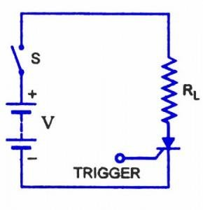

1. Natural Commutation

When the anode current is reduced be•low the level of the holding current, the SCR turns off. However, it must be noted that rated anode current is usually larger than 1,000 times the holding value. Since the anode voltage remains positive with respect to the cathode in a dc circuit, the anode current can only be reduced by opening the line switch S, increasing the load impedance RL or shunting part of the load current through a circuit parallel to the SCR, i.e. short-circuiting the device.

1. Reverse-bias Turn-off

A reverse anode to cathode voltage (the cathode is positive with respect to the anode) will tend to interrupt the anode current. The voltage reverses every half cycle in an ac circuit, so that an SCR in the line would be reverse biased every negative cycle and would turn off. This is called phase commutation or ac line commutation. To create a reverse biased voltage across the SCR, which is in the line of a dc circuit, capacitors can be used. The method of discharging a capacitor in parallel with an SCR to turn-off the SCR is called forced commutation.

In power electronic applications one advantage of using SCRs is that they are compact. The control equipment is also compact if integrated circuits are used. There has also been an attempt to miniaturize capacitors used for forced commutation and for filtering. The former use is important because the currents can be high and thermal dissipation takes high priority in design considerations. Small sizes of capacitors are at present being achieved by the use of metalized plastic film or a plastic film and aluminium foil.

1. Gate Turn Off

In some specially designed SCRs the characteristics are such that a negative gate current increases the holding current so that it exceeds the load current and the device turns-off. The current ratings are presently below 10 A and this type will not be considered further.

# 8. Differentiate natural commutation and forced commutation

Natural Commutation

* It is also called as phase commutation, line commutation or AC commutation.
* The natural commutation is only possible in the AC circuit.
* No extra circuit is necessary in order to turn off the SCR.
* The SCR turns off automatically during negative half cycle of alternating supply when reverse voltage applied across SCR for sufficient time.
* The time period of the negative half cycle should be more than the turn off time of the SCR.
* There is no power loss in the circuit because no commutation circuit.
* Class F commutation is an example of natural commutation.

Forced commutation

* It is possible only in the DC circuit.
* As there is no natural zero current in the DC circuit, extra commutation circuit ( which include L and C ) requires in order to turn off the SCR.
* The forced commutation may be voltage commutation or current commutation.
* Class A, Class B, Class C, Class D and Class E are example of forced commutation.
* Some power loss takes place in the commutation circuit.

# 10. Explain with diagram the various modes of working of TRIAC.

A Triac is a high-speed solid-state device that can switch and control AC power in both directions of a sinusoidal waveform.

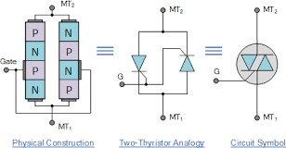

A TRIAC is a 4-layer, PNPN in the positive direction and a NPNP in the negative direction, three-terminal bidirectional device that blocks current in its “OFF” state acting like an open-circuit switch, but unlike a conventional thyristor, the triac can conduct current in either direction when triggered by a single gate pulse. Then a triac has four possible triggering modes of operation as follows.

* Ι + Mode = MT2 current positive (+ve), Gate current positive (+ve)
* Ι – Mode = MT2 current positive (+ve), Gate current negative (-ve)
* ΙΙΙ + Mode = MT2 current negative (-ve), Gate current positive (+ve)
* ΙΙΙ – Mode = MT2 current negative (-ve), Gate current negative (-ve)

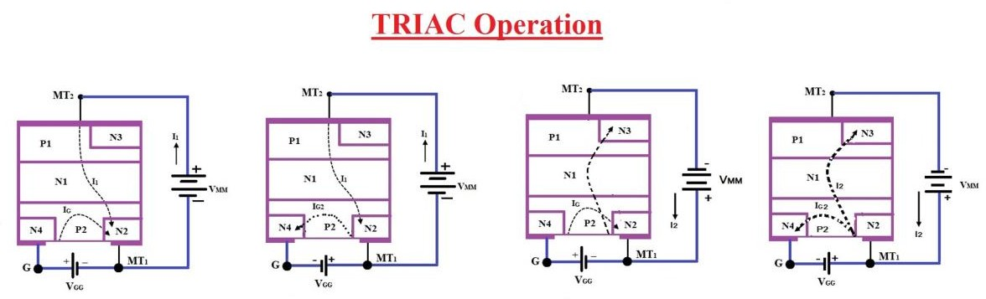

Triac I-V Characteristics Curves

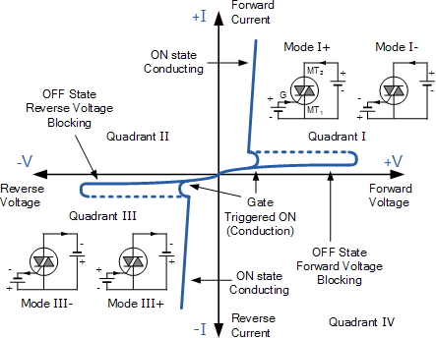

In Quadrant Ι, the triac is usually triggered into conduction by a positive gate current, labelled above as mode Ι+. But it can also be triggered by a negative gate current, mode Ι–. Similarly, in Quadrant <ΙΙΙ, triggering with a negative gate current, –ΙG is also common, mode ΙΙΙ– along with mode ΙΙΙ+. Modes Ι– and ΙΙΙ+ are, however, less sensitive configurations requiring a greater gate current to cause triggering than the more common triac triggering modes of Ι+ and ΙΙΙ–.

Also, just like silicon controlled rectifiers (SCR’s), triac’s also require a minimum holding current IH to maintain conduction at the waveforms cross over point. Then even though the two thyristors are combined into one single triac device, they still exhibit individual electrical characteristics such as different breakdown voltages,

holding currents and trigger voltage levels exactly the same as we would expect from a single SCR device.

# What is SMPS ? Mention the types of SMPS. Explain flyback SMPS in detail.

SMPS

SMPS i.e., switch mode power supply is a power supply unit that is used to deliver the power from the source to the load. Unlike linear power supplies, it involves semiconductor switching technique to provide the output signal to the load.

Generally, loads require a regulated form of dc signal as output. Through the use of SMPS, unregulated dc or ac input signal can be converted into regulated dc signal which is actually required by the load. It incorporates a switching device, which is in saturation mode when on and in cut-off mode when off. Thus, acts as an ideal switch.

SMPS Topologies

The pictorial representation of SMPS is classified:

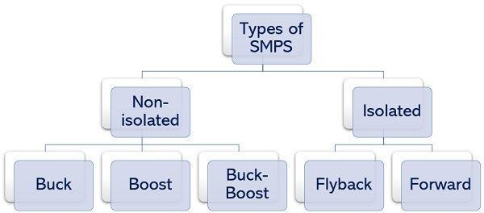

The non-isolated SMPS are the ones whose input and output circuitry are not isolated from each other. Though there many non-isolated SMPS exists, the three main types of non-isolated SMPS are Buck, Boost, and Buck-Boost SMPS. In these switch mode power supplies, no such device is used that can separate the switching circuit from that of output. Here inductors are used as energy storing elements.

While the isolated SMPS are the ones where there is isolation maintained between the input and output circuitry. Despite the existence of several isolated SMPS, the two types majorly known are Flyback Converter and Forward Converter. These switched mode power supplies make use of a transformer to separate the switching from the output.

The secondary winding of the transformer acts as the energy storing element.

It is to be noted here that the switching device can be a power transistor or MOSFET. Buck Switching Regulator

Buck switching regulator is the one that produces the dc output signal with a value less than the supplied input signal. Hence, is given another name, step down converter.

Boost Switching Regulator

A boost type of SMPS produces such a dc output signal whose value is more than the supplied input signal. Thus, sometimes called step up converter.

Buck-Boost Switching Regulator

The buck-boost configuration of SMPS produces output whose value can be more or less than the supply input depending on the condition.

Flyback Converter

In this the switching device is in complete isolation with the output circuit Forward Converter

The forward converter is also based on an isolated type of SMPS that incorporates a

transformer.

Flyback Converter

In this the switching device is in complete isolation with the output circuit

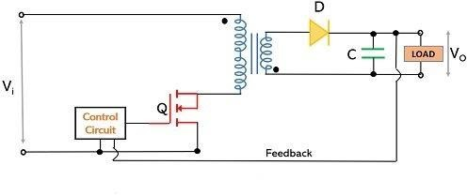

flyback transformer is incorporated, in which the only one of the windings conducts at a time. It acts as an energy storage and energy transfer device. To show the polarity of the two transformer windings, dots at both the windings are used.

During the high input pulse, the transistor will get on and the current will flow through the primary winding of the transformer and reaching the supply input. Due to this flow of current, the voltage will get induced in the secondary winding but it is of opposite polarity as the dots in the two windings are in different directions. This reverse polarity at the secondary winding, reverse biases the diode, D. In this condition, the charge stored within the capacitor acts as a source that delivers power to the load.

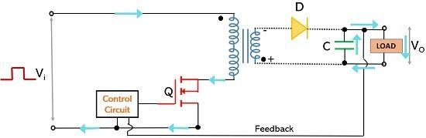

However, during the low input pulse, the transistor will be off and no current will flow through the primary winding of the transformer. At this time, the secondary winding releases energy and reverses its polarity. This forward bias the diode and current will flow through it. Hence, now the power will be delivered to the load and simultaneously the capacitor will be charged.

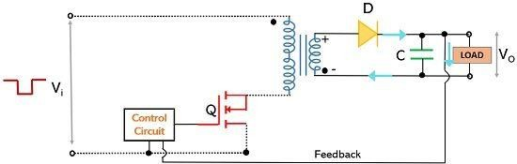

Here the turn ratio of transformer windings will determine whether the output produced will be more or less than input.

# Write short notes on Push pull SMPS, half bridge and full bridge SMPS

Push-pull Converter

A push–pull converter is a bidirectional converter that uses a transformer to provide galvanic isolation for the load and to provide voltage conversion (AC-DC and DC-DC).

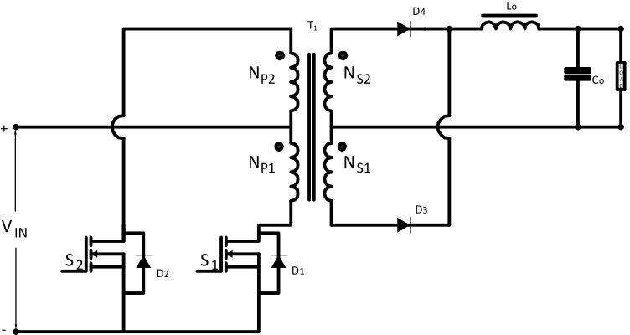

Push-Pull Converter Circuit DiagramPush-pull converters are used when there is a wide variation in the input and when the output voltage is lesser than the input voltage. They can be used at power levels in the range of 100 W to 500 W.

The transformer used in a push-pull converter consists of a center-tapped primary and a center-tapped secondary. The switches **S1** and **S2** are driven by the control circuit, with each switch driven alternately, thus driving the transformer in both directions. The

push-pull transformer is typically half the size of that for the single ended types, resulting in a more compact design.

This push-pull action produces natural core resetting during each half cycle, thus no clamp winding is required. Power is transferred to the buck type output circuit during each switch conduction period. The duty ratio of each switch is usually less than 0.45. This provides enough dead time to prevent switch cross conduction. The power can now be transferred to the output for up to 90% of the switching period, allowing greater throughput power than with single-ended types.

When switch **S1** is **ON** and switch **S2** is **OFF**, the energy is transferred to the load through transformer secondary **NS2**, **D4** and **Lo**.

When switch **S2** is **ON** and switch **S1** is **OFF**, the energy is transferred to the load through transformer secondary **NS1**, **D3** and **Lo**.

When both switches **S1** and **S2** are **OFF**, the body diode of the switch provides the path for the leakage energy stored in the transformer primary. The output rectifier diode **D3** becomes forward-biased and carries half of the inductor current through the transformer secondary **NS1**, and half of the inductor current is carried by the diode **D4** through the transformer secondary **NS2**. This results in equal and opposite voltages applied to the transformer secondaries, (both **NS1** and **NS2** have an equal number of turns) therefore, the net voltage applied across the secondary during the **Toff** period is zero.

Vout/Vin Relationship

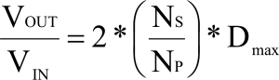

Vin > Vout

Range of duty cycle < 1 Advantages

* Power range up to several KW achievable
* To drive switches push-pull does not necessitate an isolated power supply
* Simple circuit
* High Efficiency
* Small output inductor required
* Multiple outputs possible Disadvantages
* Each switch must block twice the input voltage due to the doubling effect of the centre-tapped primary, even though two switches are used.
* The centre-tap arrangement also means that extra copper is needed for the primary, and very good coupling between the two halves is necessary to minimize possible leakage spikes. A center-tapped primary would normally be bifilar wound, but this will cause a large AC voltage between the adjacent turns.
* The high voltage (**2 • Vin**) stress on the switch and 50% utilization of the transformer primary makes using the push-pull topology undesirable when the input voltage is European, Asian, the universal range (90 VAC-230 VAC), or when PFC is used. This is why push-pull topology is most favorable for low-voltage applications such as US regulation 110 VAC input direct off-line SMPS. It has also been widely used in converters operating in 12 V & 24 V battery-powered systems.
* Another problem that can occur in a push-pull converter is the magnetic flux displacement (flux walking). If the flux swing in each half cycle is not exactly

symmetrical, the volt-sec will not balance, and this will result in transformer saturation, particularly for high input voltages. This magnetic imbalance can be caused by an unequal **Ton** period for both switches, an unequal number of turns of the primary **NP1** and **NP2** and the secondary **NS1** and **NS2**, and an unequal forward voltage drop of the output diodes **D3** and **D4**. This imbalance can be reduced by careful selection of the gate pulse drive circuitry, using a switching device, and adding an air gap to the transformer core.

* Higher component count, particularly with multiple regulated outputs. Applications
* RF Amplifier (CAR Audio)
* AC motor drivers
* DC motor drivers
* Inverters

Half-Bridge Converter

The half-bridge converter is most popular for higher power applications (up to 500 W). It is a derivative of the buck converter that uses transformer to provide galvanic isolation for the load and to provide voltage conversion (AC-DC and DC-DC).

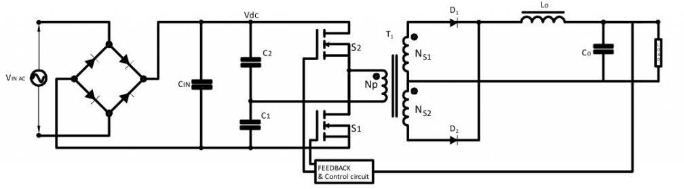

This topology also uses two major magnetic components, a transformer and an output inductor, but in this case the transformer core is better utilized than in a forward converter. The switching elements operate independently, with a dead time in between, switching the transformer primary both positive and negative with respect to the center point.

Dead times **td** between two consecutive switch conductions are absolutely mandatory to avoid a bridge-leg short circuit.

When switch **S1** is **ON** and switch **S2** is **OFF**, the energy is transferred to the load through transformer secondary **NS2**, **D2** and **Lo**.

When switch **S2** is **ON** and switch **S1** is **OFF**, the energy is transferred to the load through transformer secondary **NS1**, **D1** and **Lo**.

Vout/Vin Relationship

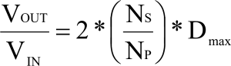

Vin > Vout

Range of duty cycle < 1 Advantages

* Voltage stress on the switch is **Vin** and this makes it much more suited to 250 VAC and PFC applications.
* Flux-walking problem is eliminated as the primary is only a single winding. A small DC blocking capacitor is placed in series with the transformer primary, to block the DC flux in the transformer core.
* High efficiency, high power density and the simplified transformer construction makes it ideal for medium power applications.
* Excellent transformer utilization, very low output ripple and small output inductor required.

Disadvantages

* High ripple current in **C1** and **C2**, which have to be carefully selected so that they do not overheat.
* Isolated driver is needed for top switch which adds component cost.
* Functioning at half of the input voltage (**Vin**) so collector current is double compared to Push-pull scheme.
* Not suitable for current mode control. Applications
* Well suited for high input voltage applications up to 440 V mains.
* Large computer supplies.
* Lab equipment supplies.

Full Bridge Converter

The full-bridge converter is a higher power version of the half-bridge and provides the highest output power level (up to 1000 W) of any of the converters discussed above.

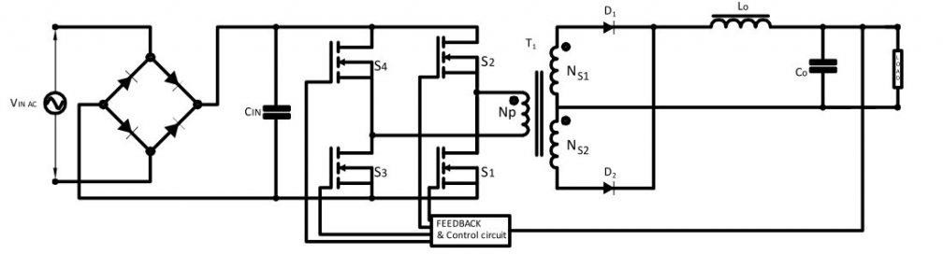

Full-bridge converters use a transformer to step down the pulsating primary voltage, as well as to provide isolation between the input voltage source and the output voltage **Vout**.

The full-bridge converter uses four switches that operate in an alternating fashion. Two diagonal switches turn **ON** and **OFF** in one PWM cycle and then the other two diagonal switches in the next PWM cycle. The flux is reset when the other switch pair is turned **ON**, so duty cycles from 0 to 1 are possible. There are two power pulses transferred each cycle, enabling the use of a smaller inductor and output capacitor.

When switch **S1**, **S4** are **ON** and switch **S2**, **S3** are **OFF**, the energy is transferred to the load through transformer secondary **NS2**, **D2**, and **Lo**.

When switch **S2**, **S3** are **ON** and switch **S1**, **S4** are **OFF**, the energy is transferred to the load through transformer secondary **NS1**, **D1**, and **Lo**.

Vout/Vin relationship

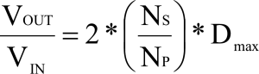

Vin > Vout

Range of duty cycle < 1

Flux imbalance may be an issue with the full-bridge converter. An optional capacitor **CB** may be added so if one switch pair conducts more current than the other pair, the voltage on **CB** will shift up or down in a manner to equalize the current flow through the switches. The *totem pole* arrangement of the switches (where one is stacked above the other) is susceptible to current *shoot-through* from the **Vbus** supply rail to the return when one switch is turning **OFF** while the other is turning **ON**. To prevent shoot- through, a dead time must be inserted between each switch transition.

Advantages

* Requiring one mains smoothing capacitor compared to two for the half-bridge saves space.
* Handles of a wide range of input and output voltage levels
* High power density
* Voltage stress on the switch is **Vin**
* High core utilization is (full flux swing in quadrants 1 and 3) allow the use of a smaller core.

Disadvantages

* Switching devices can be expensive, so it makes sense to include proper control circuits that offer good device protection, soft-start capability, and fast, high-current driver circuits.
* The timing circuit is more complex and two high-side drivers are needed.
* Higher component count particularly with multiple regulated outputs.
* Expensive as compared to other converters since it uses more components. Applications
* Computer mainframe supplies.
* Large lab equipment supplies.
* Telecommunication systems.
* DC servo motor drives.
* Generating AC voltage for AC motor drives.
* RF heating.
* Battery chargers.

# Explain L type zero current switching resonant converters.

The zero-current switching converters are of two types namely L-type and M-type. In both the circuit configurations, L and C are the necessary components that form the series resonant circuit. The presence of the inductor limits the rate of change of switching current in the circuit. Let us now discuss both the circuit configurations individually.

L-type ZCS Resonant Converters

Here the switching device used in the circuit configuration can be GTO, thyristor, BJT, MOSFET, IGBT, etc.

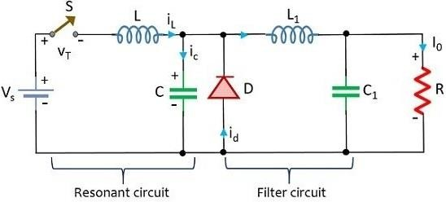

The selection of switching devices depends on the frequency range of operation. Basically, for the low-frequency range of operation, thyristor, transistor, or IGBT can be used. While in the megahertz range, power MOSFETs are used. The resonant circuit is the one consisting of L and C connected across the dc source Vdc whereas the filter circuit over here is the one consisting of L1 and C1 connected across the load.

Initially, in the steady-state condition constant current I0 flows through the load. Also, switch S in the circuit is open, so the resonant circuit parameters will be iL = 0 across the inductor and vc will be 0 across the capacitor and the load current I0 easily flows through the diode D.

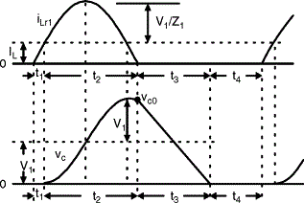

# 20. Explain zero voltage switching resonant converters

Zero voltage switching can best be defined as conventional square wave power conversion during the switch's on-time with "resonant" switching transitions. For the most part, it can be considered as square wave power utilizing a constant off-time control which varies the conversion frequency, or on-time to maintain regulation of the output voltage.

Regulation of the output voltage is accomplished by adjusting the effective duty cycle, performed by varying the conversion frequency , changing the effective on-time in a ZVS design. The foundation of this conversion is sin1ply the volt-second product equating of the input and output. It is virtually identical to that of square wave power conversion, and vastly el unlike the energy transfer system of its electrical dual, the zero current switched converter .

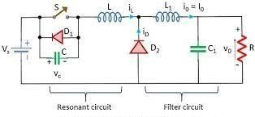

During the ZVS switch off-time, the L-C tank circuit resonates. This traverses the volt - age across the switch from zero to its peak, and back down again to zero. At this point the switch can be reactivated, and lossless zero voltage switching facilitated. Since the output capacitance of the MOSFET switch (Coss) has been discharged by the resonant tank, it does not contribute to power loss or dissipation in the switch. Therefore, the MOSFET transition losses go to zero -regardless of operating frequency and input voltage. This could represent a significant savings in power, and result in a substantial improvement in efficiency. obviously, this attribute makes zero voltage switching a suitable candidate for high frequency, high voltage converter designs. Additionally, the gate drive requirements are somewhat reduced in a ZVS design due to the lack of the gate to drain (Miller) charge, which is deleted when V DS equals zero. The technique of zero voltage switching is applicable to all switching topologies; the buck regulator and its derivatives (forward, half and full bridge), the flyback, and boost converters, to name a few. This presentation will focus on the continuous output current, buck derived topologies, however a list of references describing the others has been included in the appendix.

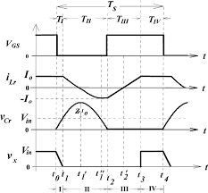

zvs Benefits .

* Zero power " Lossless " switching transitions .
* Reduced EMI / RFI at transitions .
* No power loss due to discharging Coss .
* No higher peak currents, (ie. ZCS) same as square wave systems .
* High efficiency with high voltage inputs at any frequency .
* Can incorporate parasitic circuit and componentL&C
* Reduced gate drive requirements (no "Miller" effects) .
* Short circuit tolerant

# 22. Describe the working principle of boost converter with necessary circuit and waveforms.

Boost Converters sometimes, also known as step-up choppers are the type of chopper circuits that provides such an output voltage that is more than the supplied input voltage. In the case of boost converters, the dc to dc conversion takes place in a way that

the circuit provides a high magnitude of output voltage than the magnitude of the supply input.

It is given the name ‘boost’ because the obtained output voltage is higher than the input voltage.

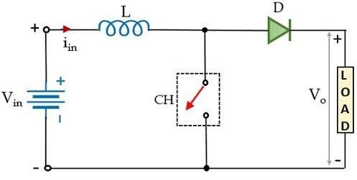

The circuit here is an elementary form of step-up chopper which necessarily requires a large inductor L in series connection with the voltage source. The whole circuit arrangement operates in a way that it helps in maintaining a regulated dc signal at the output.

Working

Initially, when the chopper CH is in on state, then in the presence of supply dc input current begins to flow through the closed path of the circuit i.e., passing through the inductor as shown in the figure below.

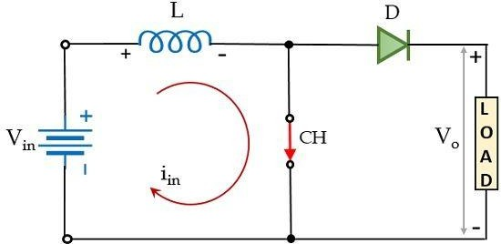

Here, the polarity of the inductor will be according to the direction of the flow of current. In this particular case, the diode in the configuration is in reverse biased condition and so current will not be allowed to flow through that particular part of the circuit during on state of the chopper. Resultantly, the voltage across the chopper will appear across the load.

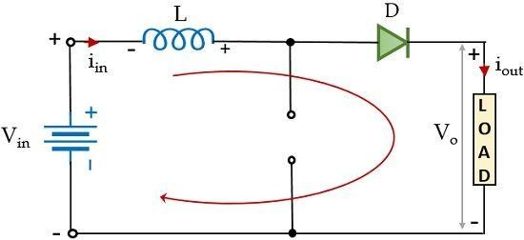

Furthermore, at the instant when CH is in the off state, then the part of the circuit through which the current was flowing earlier will not be active in this case. However, as the inductor stores, the energy in the form of a magnetic field and so the current through it will not die out instantly.

Also, we know according to Lenz’s law a reverse current will be induced that will oppose the cause which has produced it. And so, due to the induced current, the polarity of the inductor will get reversed. This reverse polarity of the inductor forward biases the diode present in the circuit. This provides the path for the current through the diode that flows through the load during the off state of the chopper i.e., Toff.

However, we must note here that the current through the inductor is of decreasing nature and will die out after a point in time.

Thus, the total voltage across the load will be given as:



This means that the output voltage exceeds the applied input voltage. Thus, performs step-up conversion as the energy stored within the inductor during the Ton period is released during the Toff period.

During the Ton period, the voltage across the inductor will be given as:



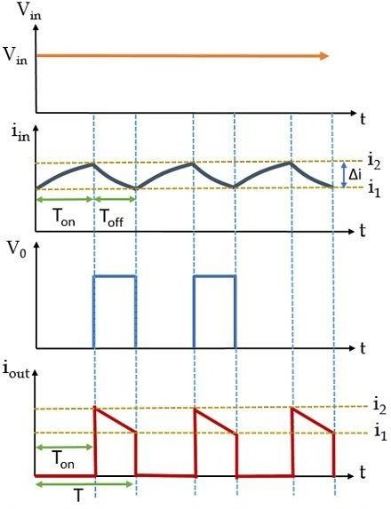

During the Ton period, the current through the inductor will change from i1 to i2 this is clearly shown above. While during the Toff period, the inductor current will change from i2 to i1. Now, talking about voltage, so during the turn-on period, the voltage across the inductor will be equal to the supply input voltage. But when CH gets off then on applying KVL in the figure shown above, we will get,



This means,



Considering that output current is varying linearly, the energy input provided by the source to the inductor, when CH is on, is given as:

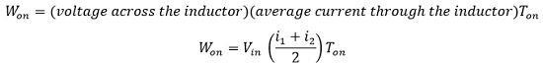

Further, the energy that the inductor releases to the load when CH is off is given as:

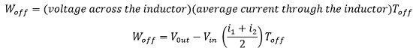

For a lossless system, comparing the two energies, we will have,



On simplifying,

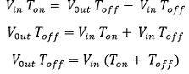

Since we know, T = Ton + Toff, therefore,

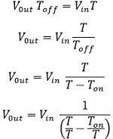

Since, we know, duty cycle i.e., α = Ton/ T



Thus, we can conclude here that the average load voltage can be stepped up with the change in the duty cycle.

Applications

Due to the operating principle of step-up choppers, these find applications in the regenerative braking of dc motors. Along with this, these are used in various consumer electronics, battery power systems, power amplifier circuits, power factor correction circuits, automotive equipment, etc.

# 28. Draw the circuit diagram of current source inverter and explain its operation with relevant waveforms.

Current Source Inverter is a type of inverter circuit that changes the dc current at its input into equivalent ac current. It is abbreviated as CSI and sometimes called a current fed inverter. Here the input provided to the circuit is a stiff dc current source rather than dc voltage source.

In CSI, the input voltage is kept invariable and the amplitude of output voltage does not show dependency on load. But the waveform representation and the magnitude of the current flowing through the load depends upon the nature of the load impedance.

Single-phase Current Source Inverter

The figure represents the circuit representation of a single-phase current source inverter with ideal thyristors:

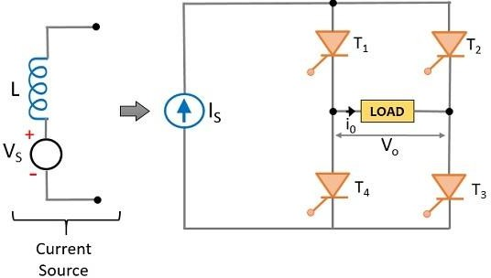

An assumption regarding thyristor is made over here that it possesses zero commutation time. Here we are having a voltage source in series with an inductor that provides constant current at the input terminal of the current source inverter. More simply, we have realized a high current source by using the inductance of a specific value and a limited dc voltage source.

Although there are four thyristors in the configuration pair of T1-T3 and T2-T4 conduct alternatively. Initially when thyristors T1 and T3 are on then the current Is flows through the load bypassing through thyristors T1 and T3. When T1 and T3 conduct then the current flows through the load and the load current is positive and equal to the applied input current.

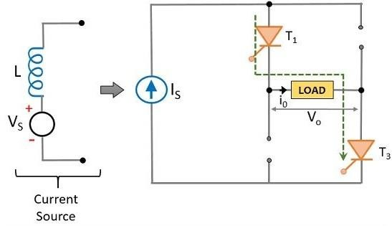

While when T2 and T4 are on then the direction of flow of load current is opposite to the former case and so the load current will be negative but equivalent to the applied input current. A noteworthy point over here is that in both cases the frequency of the obtained output waveform shows dependency on the triggering instant of the thyristors.

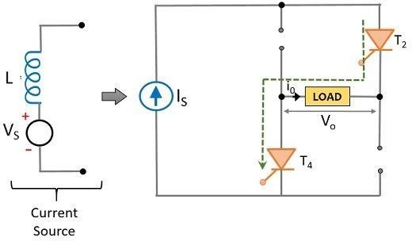

The square wave shown below represents the output of an ideal single-phase current source inverter :

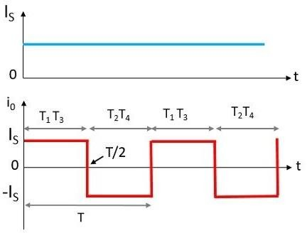

Here the amplitude of the square wave obtained is equal to the magnitude of applied dc input current. It can be clearly seen from the waveform representation that the two pairs of thyristors get turned on alternatively and possess a reverse direction of flow of current.

Like the case of voltage source inverter, here also we have assumed that a pair of thyristor conducts only until the gate triggering pulse is provided to them and the moment it is removed from one pair, the triggering pulse must be immediately provided to another pair. In the above figure, it can be clearly seen that the triggering is transferred from one pair to another at instant T/2. More simply, between the instant 0 < t < T/2, T1-T3 thyristor pair is triggered while between the instant T/2 < t < T, T2-T4 thyristor pair is triggered.

If we consider the load to be capacitive then the load current will be given as:



As the supply input is invariable and so the load current *i*0

thus the rate of change of

voltage across the load must also be constant over every half cycle.

It is to be noted here that the dc input current applied to the load possesses unidirectional behavior. This means that if the power flows from source to load then the direction of current is positive while if power flows from load to source then the direction of current will be negative corresponding to the regeneration of power.

Ideally, we have shown here that a proper square wave pulse is obtained at the output. However, in the case of practical implementation, this is not actually possible and the reason behind it is that such an instantaneous rise and fall of current is not possible to get.

Advantages

* It offers easy operation as the circuit working is controlled by controlled current source i.e., the combination of current limited voltage source serially connected to the large inductance.
* The circuit is designed in a way that it can handle large voltage spikes at the time of commutation.
* The four-quadrant operation can be achieved without the need for extra power usage.

Disadvantages

* An unstable performance is noticed at light load and high-frequency operation.
* The commutation of the thyristor in the circuit shows dependency on the load current which limits the operating frequency.

➢

# 31. Draw the circuit diagram of three phase to single phase cycloconverter and explain its operation with waveforms.

A cycloconverter (CCV) or a cycloinverter converts a constant voltage, constant frequency AC waveform to another AC waveform of a lower frequency by synthesizing the output waveform from segments of the AC supply without an intermediate DC link

One particular property of Cycloconverters is that it does not use a DC link in the conversion process thus making it highly efficient. The conversion is done by using power electronic switches likes Thyristors and switching them in a logical manner. Normally these Thyristors will be separated into two half, the positive half and the negative half. Each half will be made to conduct by turning them during each half cycle of the AC form thus enabling bi-directional power flow.

Three Phase to Single Phase Cycloconverters:

The Three Phase to Single Phase CCV is also similar to the Single Phase to Single Phase CCV, but in here the input voltage is a 3 Phase supply and the output voltage is a Single Phase supply with variable frequency. The circuit also looks very similar except we will need 6 SCR in each set of Rectifier since we have to rectify the 3 Phase AC voltage.

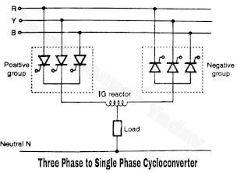

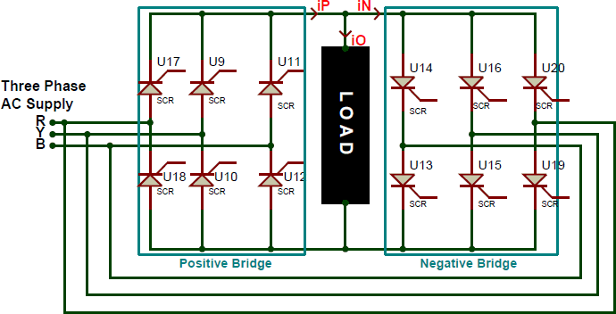

Again the gate terminals of the SCR will be connected to the control circuit for triggering them and the same assumptions are made again to understand the working easily. Also there are two kinds of Three Phase to Single Phase CCVs , the first type will have a half wave rectifier for both Positive and Negative Bridge and the second type will have a full-wave rectifier as shown above. The first type is not used often because of its poor efficiency. Also in a full-wave type both the bridge rectifiers can generate voltages in both the polarity, but the positive converter can supply current (source) only in the positive direction and the negative converter can drain current only in negative direction. This allows the CCV to operate in four Quadrants. These four quadrants are (+V, +i) and (-V, -i) in rectification mode and (+V, -i) and (-V,-i) in inversion mode.

Operation of Three Phase to Single Phase Cycloconverter :

* As shown in Figure, there are two three phase half wave circuits connected to the common load. These are called as the positive and negative groups.
* The principle of operation is based upon progressively varying the firing angle a of SCRs connected in one of the groups.
* If we want the load voltage to be positive then the SCRs of positive group should be fired whereas in order to produce a negative output voltage, the SCRs from negative group should be turned on.

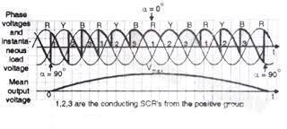

* The load voltage waveform of Figure . so as to produce the positive mean output voltage, the SCRs of the positive group are turned on.
* But more importantly , the firing angle a is first reduced progressively from 90° to 0o so that the mean output voltage increases from OV to peak positive voltage sinusoidally. The firing angle is then increased progressively from 0o to 90° in order to reduce the mean output voltage sinusoidally from peak positive voltage to zero volt.
* We can apply the same principle to produce the negative half cycle of the mean output voltage. To produce the negative half cycle of the mean output voltage, we have to turn on SCRs only from the negative group and vary their firing angle progressively from 90° to 0° and then from 0o to 90° as discussed for the positive group SCRs.